In Radon Awareness Week, employers are being urged to familiarise themselves with a new lower threshold for permissible levels of radon exposure at work under the forthcoming update to the Ionising Radiation Regulations.
- Radon is the second leading cause of lung cancer
From January 2018, employers will have to adhere to a new lower radon exposure limit of 300Bq/ m3 in the workplace, replacing the current 400Bq/ m3 threshold.
If radon is found above this new lower “action level”, employers will be required to take action to restrict resulting exposures.
Under the reforms, the HSE will also overhaul how organisations notify the watchdog of unsafe levels of exposure.
As a result, organisations will only be required to notify HSE once efforts to remediate radon exposure show that levels cannot be reduced below the new 300Bq/m3 limit.
Radon is the second largest cause of lung cancer in the UK, with around 1100 deaths a year attributed to it. It is a colourless, odourless radioactive gas that decays to produce radioactive by-products that can damage lung cells when inhaled.

"To comply with new regulations, employers need to act now to ensure they have a robust and effective strategy in place to protect employees from radon exposure and to meet the imminent new safety standards."
Every building contains radon to some degree but the levels are usually low, with the chances of a higher level depend on the type of ground and the location.
According to a white paper by consultant Bureau Veritas, Radon: Achieving Workplace Statutory Compliance, basements and poorly ventilated ground floor rooms are more at risk, as radon is more likely to enter a building from the ground, and ventilation is typically worse.
In densely populated areas, the risk can also be greater, as it is more likely that homes and workplaces – including factories offices and shops – would occupy the lower ground rooms.
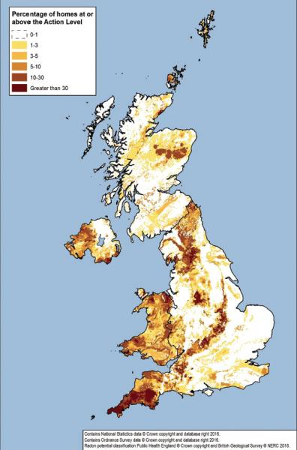
Under the Management of Health and Safety at Work Regulations 1999, all workplaces should carry out a radon risk assessment if they operate below ground workplaces that are occupied more than an hour per week, or 52 hours per year.
Alternatively, there must be testing if they fall in radon affected areas (>30%) as identified by Public Health England’s UK radon heat map.
The Ionising Radiations Regulations 1999 (IRR99) come into effect where radon is present above the defined level of 300 Bq/m3 and employers are required to take action to restrict resulting exposures.
The 300 Bq/m3 threshold compares to an action level of 200 Bq/m3 for homes, taking into account that most people spend much more time in their home than at work.
The HSE and Local Authorities are responsible for enforcing these regulations in particular types of workplace.
The map, produced by Public Health England, shows where high levels are more likely, with darker colour areas having a greater the chance of a higher level of radon.
In white areas, the chance is less than one home in a hundred homes being affected, but this rises to one in three homes in the darkest areas.
Ian Mitchell, a principal consultant at Bureaus Veritas, said: “We hope that Radon Awareness Week, as well as upcoming changes to legislation, will finally put radon on the radar for many organisations.
“For years, we’ve come to know carbon monoxide as the ‘silent killer’. The reality is, however, that as the second leading cause of lung cancer in UK, radon exposure presents a much more pressing danger.
“The potential risk from radon affects all employees working at ground and below ground workplaces, which include offices, banks and retail premises in all geographic locations across all of the UK. Yet this risk is often overlooked, despite the well understood health implications associated with exposure to radon gas through a typical working day.
“To comply with new regulations, employers need to act now to ensure they have a robust and effective strategy in place to protect employees from radon exposure and to meet the imminent new safety standards.
Meanwhile, a campaign from the UK Radon Association, Looking out for little lungs, highlights the fact that exposure to naturally-occurring radon gas is the leading cause of lung cancer in non-smokers, responsible for over 1100 deaths in the UK every year.
Whilst long term exposure to radon is harmful to everyone regardless of age, the campaign points out that children are more susceptible to lung damage.
Dr Aaron Goodarzi, a Canadian professor and expert in genome damage caused by radon says: “Exposure to radon during childhood significantly increases the risk of developing lung cancer later in life.
“Indeed, childhood (ages 0–17 years) exposure to even moderately high radon concentrations (400 Bq/m3) is equivalent to a lifetime exposure at 100 Bq/m3 radon concentration.
“Thus, while it is advisable for anyone to test their homes and workplaces for radon (and mitigate if a problem is detected), any homes, schools, and childcare centres where small children and young adults spend a great deal of time should become a priority for radon elimination.”

